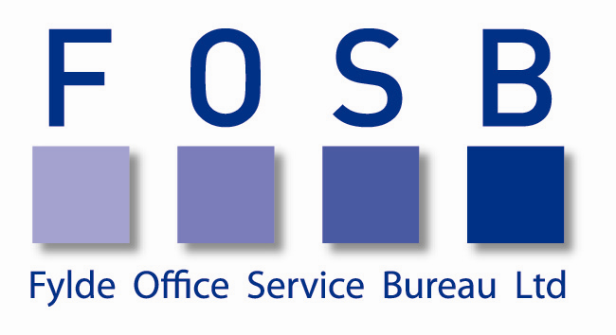
Health & Safety Statement
It is the policy of Fylde Office Service Bureau Ltd (“the Company”) to foster a positive health and safety culture throughout the Company because we believe that high standards of health and safety are a moral and commercial pre-requisite.

The Company is committed to:
- providing adequate control of the health and safety risks arising from our work activities
- working to prevent accidents and work related ill health
- providing and maintaining safe equipment
- maintaining safe and healthy working conditions, and adequate welfare facilities
- ensuring all employees are competent to do their tasks, and to give them adequate training
- ensuring the safety of our clients/customers/temporary workers at all times
- reviewing and revising this policy statement annually

The Company is committed to the safety of its temporary workers by:
- ensuring that the Temporary Worker completes a Health Statement prior to them starting an assignment
- following the Health Policy/Procedure should Statement 2 be declared
- liaising with the Client regarding any health or safety issues
- ensuring that the Client knows that it is their responsibility to include the Temporary Worker in their own Health & Safety Induction/Training policies.

Implementation, maintenance and review
The overall responsibility for health and safety lies with the most senior person in the company. The Director, David Parry accepts overall responsibility for all Health and Safety within the Company and is responsible for all policy implementation. Any queries or further information should be directed to him.
The company will strive to maintain excellence in health and safety matters and in this respect, employees and others are encourage to co-operate with the management in all safety matters, to identify hazards and reduce the risk which may exist during work activities and to report any condition which may appear dangerous or unsatisfactory. The Company will a tall times consult with the employees on these matters.
The Director will, so far as reasonably practicable, ensure that the Company provides adequate financial resources to meet these objectives.

